***AURA GOLD LEATHER:***

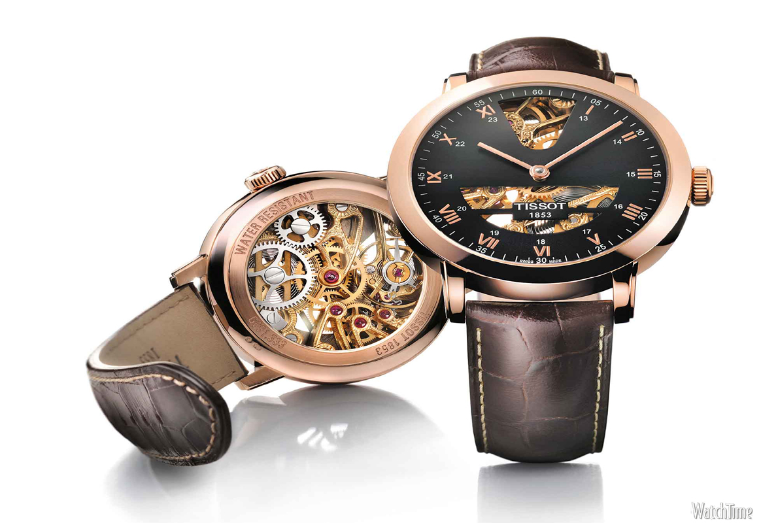

***DETAILS ABOUT THIS WATCH:***

Buckle/Clasp: Clasp (Self-Adjust)  
Case Color: Rose Gold-Tone  
Case Finish: Brushed/Polished  
Case Shape: Round  
Case Size: Small Size  
Crystal/Lens: Mineral Glass

***SPACES:***

**DIAL COLOR:**Beige

**CASE SIZE:**34mm

**CASE SHAPE:**Round

***Price:***

***Rs:3,500***